Window handling in selenium:

To handle the window in selenium we have to use the id of individual window so that we can switch them on the basis of id.

Window which gets launch first is called as Parent window and whose id can be get by driver.getWindowHandle();

Windows which get launch after the parent is called child window, to get the id of child and parent we have to call driver.getWindowHandles().

getWindowHandle() return – String

getWindowHandles() return –Set< String> because in Set Collection we don’t allow duplicate values.

Example:

**public** **static** **void** main(String[] args) {

System.*setProperty*("webdriver.chrome.driver", "E:\\desktop\\Katraj\\15 Jan\\Selenium\\chromedriver.exe");

WebDriver driver = **new** ChromeDriver();// chrome browser will get open

driver.manage().window().maximize();// to maximize the window

driver.get("https://opensource-demo.orangehrmlive.com/index.php/dashboard");

String parentid = driver.getWindowHandle();

System.***out***.println("Parent id is :"+parentid);

WebElement link = driver.findElement(By.*xpath*("//*[text()='OrangeHRM, Inc']"));

link.click();

Set<String> allwinid = driver.getWindowHandles();

**for**(String id:allwinid)

{

System.***out***.println(id);

}

}

}

Output:

Parent id is :CDwindow-AB153FC8BCE5DFA1CE204F8D7388DCF7

CDwindow-AB153FC8BCE5DFA1CE204F8D7388DCF7

CDwindow-7E4EF218C3E9DCEE4393EC4962871EB5

To switch the window we have to use :

**public** **static** **void** main(String[] args) {

System.*setProperty*("webdriver.chrome.driver", "E:\\desktop\\Katraj\\15 Jan\\Selenium\\chromedriver.exe");

WebDriver driver = **new** ChromeDriver();// chrome browser will get open

driver.manage().window().maximize();// to maximize the window

driver.get("https://opensource-demo.orangehrmlive.com/index.php/dashboard");

String parentid = driver.getWindowHandle();

System.***out***.println("Parent id is :"+parentid);

WebElement link = driver.findElement(By.*xpath*("//*[text()='OrangeHRM, Inc']"));

link.click();

Set<String> allwinid = driver.getWindowHandles();

**for**(String id:allwinid)

{

**if**(!(id.equals(parentid)))

{

driver.switchTo().window(id);

driver.get("https://www.google.com");

}

System.***out***.println(id);

}

Close() vs quit(): Close()is used to close the current window on which the focus is available.

Quit() this will close all the windows which got open during the automation process.

Switching windows when we have multiple child window available:

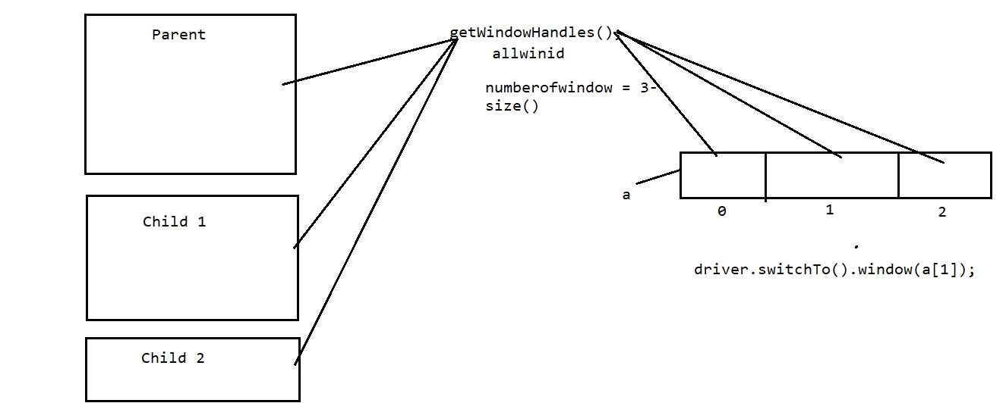

Handling more than 2 child windows:

**public** **static** **void** main(String[] args) {

System.*setProperty*("webdriver.chrome.driver", "E:\\desktop\\Katraj\\15 Jan\\Selenium\\chromedriver.exe");

WebDriver driver = **new** ChromeDriver();// chrome browser will get open

driver.manage().window().maximize();// to maximize the window

driver.get("https://opensource-demo.orangehrmlive.com/index.php/dashboard");

String parentid = driver.getWindowHandle();

System.***out***.println("Parent id is :"+parentid);

WebElement link = driver.findElement(By.*xpath*("//*[text()='OrangeHRM, Inc']"));

link.click();

link.click();

link.click();

Set<String> allwinid = driver.getWindowHandles();

**int** numberofid = allwinid.size();

**int** i =0;

String [] winid = **new** String[numberofid];

**for**(String id:allwinid)

{

winid[i]=id;

i++;

}

driver.switchTo().window(winid[2]);

driver.get("https://www.google.com");

}

}